1. Import the data set into HDFS.

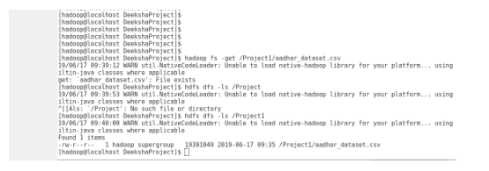

2. Create a Hive table ‘uid_enrollment_detail’ corresponding to the given Input dataset using HQL ‘create’ command.

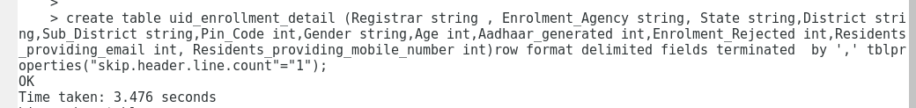

3.Load the HDFS dataset into the Hive table using the HQL ‘load’ command

